**Ideation:**

Crude oil market is very difficult and changing environment and hence the process of predicting those changes in such a difficult environment becomes challenging and difficult with regards to its accuracy. A number of approaches have been implemented to tackle that challenge and Machine Learning (ML) has been at the core in many of them. There are immense of examples of algorithms related to machine learning which gives satisfactory results with accuracy for predicting crude oil market price. The ideation to predict crude oil prices using Long Short-Term Memory (LSTM) based recurrent neural networks. Our idea is to experiment with various types of models using number of epochs, lookbacks and other tuning methods. To get best results and accuracy Long Short-Term Memory (LSTM) based recurrent neural networks can be implemented.

Recurrent Neural Network (RNN) are a type of Neural Network where the output from previous step is given as input to the current step. They use their internal memory for prediction. RNN have a “memory” which remembers all information about what has been calculated and evaluated. It uses the same parameters for every input as it does the same task on all the inputs or hidden layers to predict the result. This reduces the complexity of parameters, unlike other neural networks. They are implemented for many applications such as handwriting recognition and speech recognition. The Neural Networks uses sequential information which are available to them.

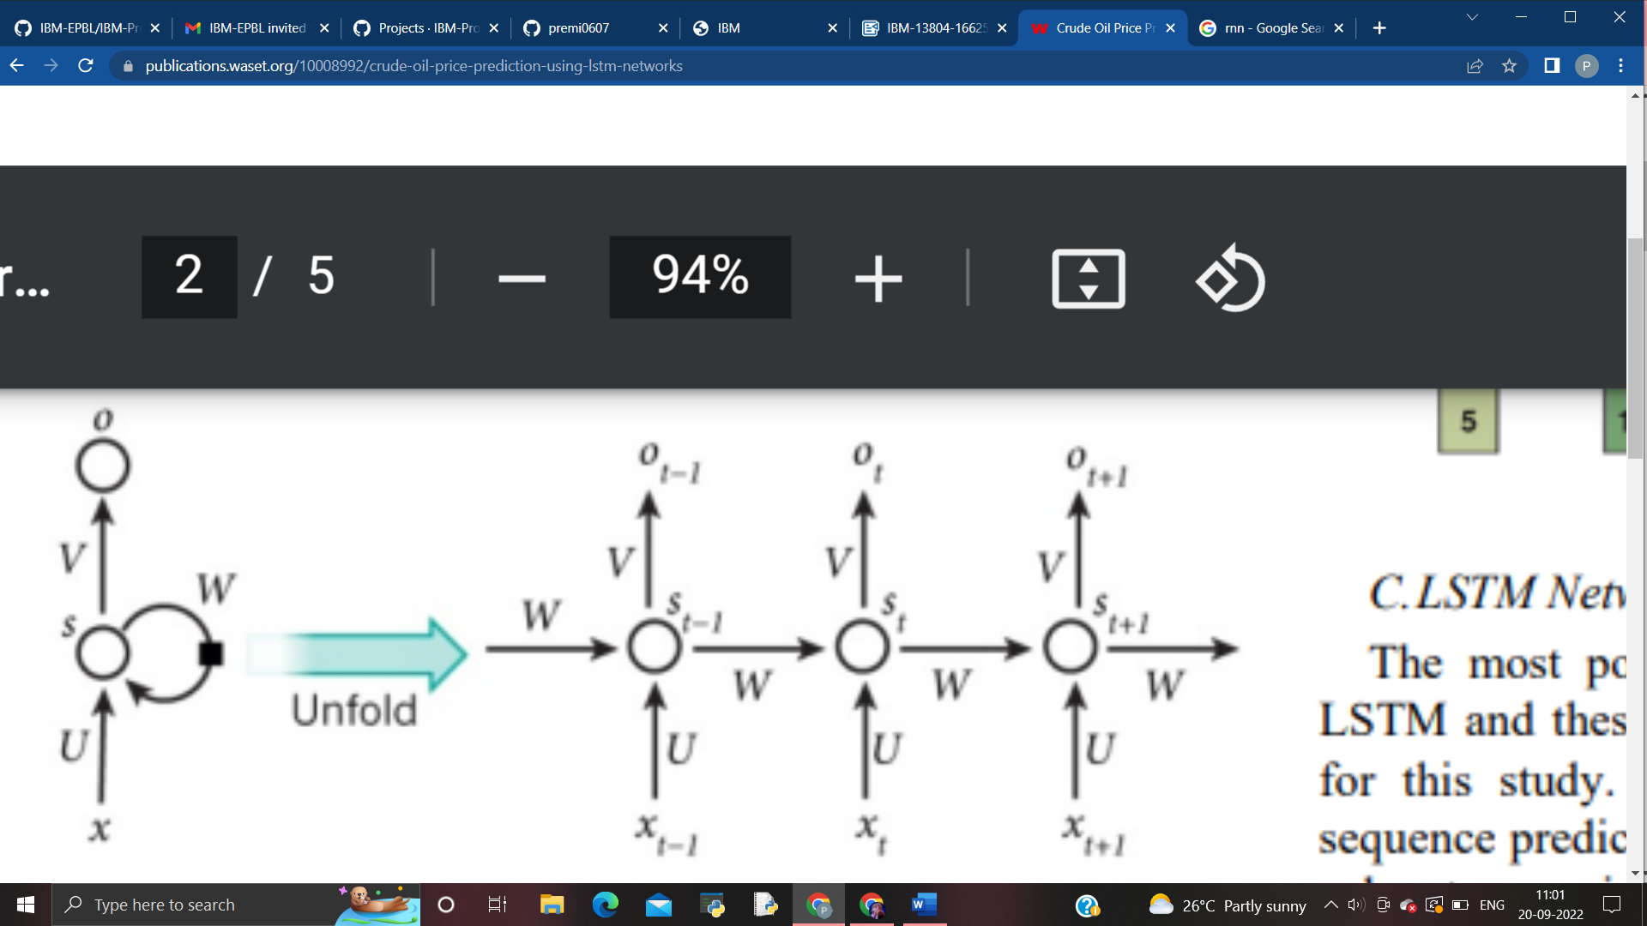

The most popular and widely used type of Recurrent Neural Network is the Long Short-Term Memory (LSTM). These recurrent neural networks learn order dependence in continuous values or sequence prediction problem. The LSTM networks overcomes two major issues which is encountered in RNN. The two issues are vanishing gradients and exploding gradients. The key to the solution of these problems was the internal structure that has been used in LSTM. The simple architecture of LSTM networks is called as vanilla LSTM which performs very well in all sequence related prediction problems.

